

Tabby, come home

Animal communicator steered owner to cat missing 14 months
by Patricia M. Murret | Staff Writer
Anyone who ever cried at the movie "Lassie, Come Home" may want to call Nancy Ruffner of Gaithersburg, who smiled Saturday as she played with her recently returned family cat, Sam.
The orange and white tabby she bought as a birthday gift to her daughter Laura 11 years ago went missing in November 2008, she said. Fourteen "heart-wrenching" months later, she found him again, with the help of a Georgia-based animal communicator.
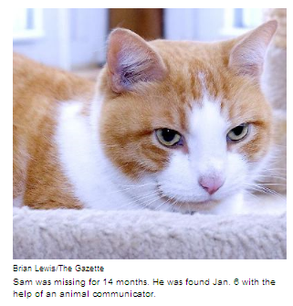
"I still can't believe it," said Ruffner, 56, who is a nurse at Redland Middle School in Derwood, Cashell Elementary School in Rockville and Sequoyah Elementary School in Derwood.
The Flower Hill woman and her family had exhausted all possibilities before she contacted Tim Link, founder and chief executive officer of Wagging Tales Inc. in Cumming, Ga., one more time in December, she said.
Sam went missing Nov. 12, 2008, Ruffner said. She contacted the Montgomery County Humane Society and checked shelters. She put fliers in Flower Hill grocery stores, pet stores, video stores, fast food restaurants and gas stations.
Looking for Sam became "a never-ending job," Ruffner said. But she never gave up hope.
Early on, Ruffner reached out to a professional dog tracker and, as "a shot in the dark," contacted several animal communicators she found online, she said. She paid Link $95 in January 2009, and he sent her to an address off Emory Grove Road, but she did not find Sam.
"And I kind of thought that I was on a wild goose chase," Ruffner said.
But she decided over the December holidays to try again.
Link, a former telecommunications salesman, said he has helped animal owners full time since 2007.
Link said he uses his "intuitive connection" to ask animals questions and they respond, sharing information through words, colors and emotions. He discovered his gift in 2004 at a workshop for people hoping to find a deeper connection with animals, he said.
After Ruffner paid Link another $95, he asked Sam via telepathy to describe his whereabouts and used a map and pendulum "to find where the energy was," Link said.
Then he gave Ruffner two addresses in Gaithersburg, one on Chelsey Knoll Drive, the other off Snouffer School Road, and described surrounding houses.
Ruffner put up posters at the spots on New Year's Eve. On Jan. 6, her cell phone rang. A man said, "I think I have your cat looking at me."
As Link had predicted, Ruffner's cat was living in a garage on Chelsey Knoll Drive. The caller was renting the house, which is about 1.25 miles from her home. The man told Ruffner he had an orange and white cat also named Sam when he was growing up, so when he spotted a similar cat roaming the neighborhood a month earlier, he took him in.
"There's lots of really weird things that makes me wonder if it's lots of coincidences," said Ruffner, who rushed Sam, who had been micro-chipped, to the veterinarian to confirm his identity. "Otherwise there was some kind of divine intervention going on."
Ruffner said she does not know where Sam had spent the other 13 months.
The cat is generally in good health, she said.
But Sam has been restless since arriving home, said Ruffner and Link. Link said he sent the cat "some Reiki energy remotely" to help him reduce stress and get readjusted.
Copyright © 2010 Post-Newsweek Media, Inc./Gazette.Net

